**Java Interview Questions**

1. Why is Java a platform independent language?
   1. Java language was developed in such a way that it does not depend on any hardware or software due to the fact that the compiler runs the code and then converts it to platform-independent byte code which can be run on multiple systems
2. Why is Java not a pure object oriented language?
   1. Java supports data types
      1. Byte
      2. Boolean
      3. Short
      4. Int
      5. Float
      6. Long
      7. Double
3. What do you understand by an instance variable and a local variable?
   1. Instance variable – variables declared outside the methods and inside the class, are accessible by all methods
   2. Local variables – variables declared within the methods and can only be used within the methods it was declared
4. What is data encapsulation?
   1. Concept of hiding the data attributes and their behaviors in a single unit
   2. Helps developers to follow modularity
5. Tell the difference between equals() method and equality operator (==) in java?
   1. Equals() method
      1. Method defined in the Object class
      2. Used for checking the equality of contents between two objects
   2. Equality Operator (==)
      1. Operator is used for comparing addresses (or references) if both the objects are pointing to the same memory location
6. What is concept of Constructor overloading?
   1. Constructor overloading is the process of creating multiple constructors in the class consisting of the same name with a difference in the constructor parameters
   2. 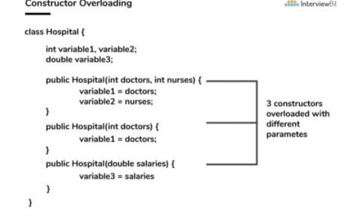
7. Difference between method overloading and method overrirding
   1. Method overloading
      1. Introducing different methods with the same name, but with different number of parameters
      2. 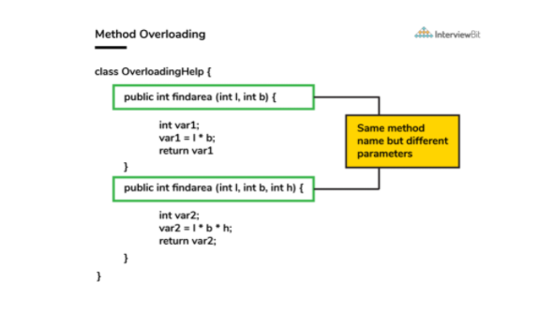
   2. Method overriding
      1. Concept in which two methods have the same name but perform different functionality
      2. 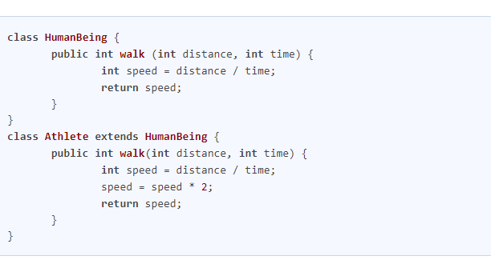
8. Can a try block and multiple catch blocks co-exist in a java program
   1. Yes, multiple catch blocks can exist but specific approaches should come to prior to the general approach because only the first catch block satisfying the catch condition is executed
9. Difference between a final variable, final method, and final class
   1. Final variable
      1. When a variable is declared as final in Java, it cannot be modified once it has been assigned
   2. Final method
      1. A method declared as final cannot be overridden by its children classes
   3. Final class
      1. No classes can be inherited from the class declared as final.
      2. That final class can extend other classes for its usage
10. Final, Finally, Finalize keywords
    1. Final
       1. When a variable is declared as final in java, it cannot be modified once it has been assigned.
       2. Becomes fixed
    2. Finally
       1. It is the block present in a try catch block
       2. Usually the last block that is performed after the try and catch blocks
    3. Finalized
       1. Finalize method is called so that the clean up activity is implemented
11. When can you use super keyword?
    1. Super
       1. Keyword is used to access hidden fields and overridden methods or attributes of the parent class
    2. Following Scenarios
       1. Accessing data members of parent class when the member names of the class and its child subclasses are the same
       2. To call the default and parameterized constructor of the parent class inside the child class
       3. Accessing the parent class methods when the child classes have overridden them
12. Can static methods be overloaded? Overridden?
    1. Overloading - Yes, there can be two or more static methods in a class with the same name but differing input parameters
    2. Overriding – they cannot
13. What is the main objective of garbage collection?
    1. Main objective is to free up the memory space occupied by the unnecessary and unreachable objects during the Java program execution by deleting unused objects
       1. Ensures that the memory is used efficiently
14. What part of memory (Stack of Heap) is cleaned in garbage collection process?
    1. Heap
15. What are the reasons behind making strings immutable in Java?
    1. Utliize string pool to facilitate sharing
    2. An immutable class is needed to facilitate it
    3. Sharing of mutable structures between two unknown parties is not possible
    4. Multithreading – cleaner code can be written for sharing string objects since no external synchronization is required
    5. Collections – changing state poses a lost of risks when residing in the hashamaps
16. Differences between String, StringBuilder, and StringBuffer
    1. Storage Area
       1. String – String pool serves as the storage area
       2. StringBuilder – heap memory is the storage area
       3. StringBuffer – heap memory is the storage area
    2. Mutability
       1. String – immutable
       2. StringBuilder – mutable
       3. StringBuffer – mutable
    3. Efficiency
       1. String is slow
       2. StringBuidler is the fastest in performing operations
       3. StringBuffer is faster than String but slower than StringBuilder
    4. Thread Safe
       1. StringBuilder and Stringbuffer are used in threaded environment
       2. StringBuilder better for single thread
       3. StringBuffer better for multiple threads
    5. 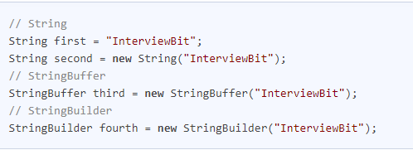
17. Difference Between Interfaces and Abstract classes
    1. Availability of methods
       1. Only abstract methods are available in interfaces, whereas non-abstract methods can be present along with abstract methods in abstract classes
    2. Variable types
       1. Static and final variables can only be declared in the case of interfaces, whereas abstract classes can also have non-static and non-final variables
    3. Inheritance
       1. Multiple inheritances are facilitated by interfaces, whereas abstract classes do not promote multiple inheritances
    4. Data member accessibility
       1. By default the class data members of interfaces are of the public type
       2. Class members for an abstract class can be protected or private also
    5. Implementation
       1. With the help of an abstract class, the implementation of an interface is easily possible
       2. Implementation of an abstract class is not possible
18. Difference between HashSet and TreeSet
    1. Implementation
       1. HashSet – hash table is utilized for storing the elements in an unordered manner
       2. TreeSet – makes use of the red-black tree to store the elements in a sorted manner
    2. Complexity/Performance
       1. HashSet – for adding, retrieving and deleting elements, the time amortized complexity is O(1)
          1. Faster than Treeset
       2. TreeSet – time complexity for performing the same operations is a bit higher and is equal to O(log n)
    3. Methods
       1. hashCode() and equals() are the methods utilized by HashSet for making comparisons between the objects
       2. compareTo() and compare() methods are utilized by TreeSet to facilitate object comparisons
    4. Object Types
       1. HashSet – heterogenous and null objects can be stored
       2. TreeSet – runtime exceptions occurs while inserting heterogenous and null objects
19. Why is the character array preferred over String for storing confidential information?
    1. Helps in saving heap memory and also gives no chance to the hackers to extract vital data
       1. Vital information can be stolen for pursuing harmful activities by hackers if a memory dump is illegally accessed by them
       2. Such risks ca be eliminated by using mutable objects or structures like character arrays for storing any variable
20. What is the differences between HashMap and HashTable?
    1. HaspMap
       1. Not synchronized thereby making it better for non-threaded applications
       2. Allows only one null key but any number of null in the values
       3. Supports order of insertion by making of its subclass LinkedHashMap
    2. HashTable
       1. HashTable is synchronized and hence it is suitable for threaded applications
       2. This does now allow null in both keys or values
       3. Order of insertion is not guaranteed in HashTable
21. What are different ways of thread usage ?
    1. Extend the Thread class
    2. Implement the Runnable interface
       1. Is more preferred as Java does not have support for multiple inheritances of classes
22. What are the differences between constructor and method of a class in Java?
    1. Constructor
       1. Used for initializing the object
       2. Has no return type
       3. Gets invoked implicitly
       4. If constructor is not defined, then a default constructor is provided by compiler
       5. Constructor name should be equal to class name
       6. Cannot be marked as final
       7. Final variable instantiations are possible inside a constructor and the scope of this applies to the whole class and its objects
    2. Method
       1. Used to expose objects behavior
       2. Should have a return type
       3. Has to be invoked explicitly
       4. If it is not defined, compiler does not provide it
       5. Name of the method can have any name or have a class name too
       6. Method can be defined as final
       7. Final variable if initialized inside a method ensures that the variable cant be changed only within the scope of that method
23. What happens if the static modifier is not included in the main method signature in Java?
    1. There would not be any compilation error
    2. But then the program is run, since the JVM cant map the main method signature the code throws NoSuchMethodError at the run time
24. What happens if there are multiple main methods inside one class in Java?
    1. Will not compile since main method has already been defined
25. Is exceeding the memory limit possible in a program despite having a garbage collector ?
    1. Yes it is possible
       1. Not enough memory to create new object
26. What could be the tradeoff between the usage of an unordered array versus the usage of an ordered array ?
    1. Main advantage of having an ordered array is the reduced search time complexity of O(log n) rather than O(n)
    2. Main drawback of the ordered array is its increased insertion time which is O(n) due to the fact that its element has to reorder to maintain the order of array during every inserting whereas the time complexity in the unordered array is only O(1)

**Data Structures**

1. Set
   1. Extends the Collection interface
   2. Unordered collection of objects in which duplicate values can be stored
   3. Methods
      1. Add(element) – used to add a specific element to the set only if it is not already present
         1. 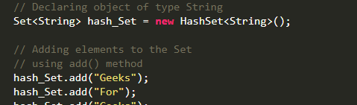
      2. contains()
         1. after elements are added, this can be used to access the elements
            1. 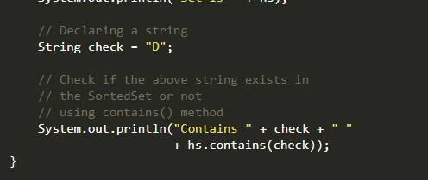
      3. Remove()
         1. Values can be removed from Set
            1. 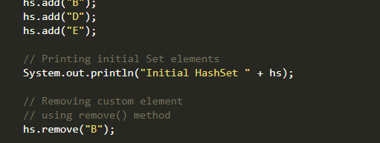
2. Stack
   1. Based on the principle of last-in-first-out
   2. Includes additional functions of empty, search, and peek
   3. Methods
      1. Push()
         1. Adds element to the stack
            1. 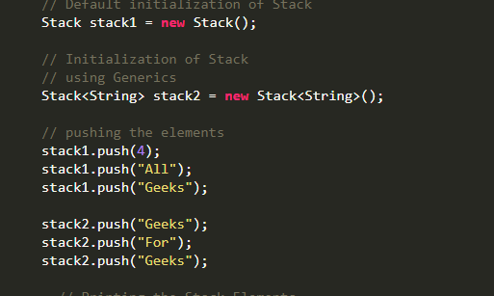
      2. peek()
         1. retrieve or fetch first element of the stack or the element present at the top of the Stack
            1. 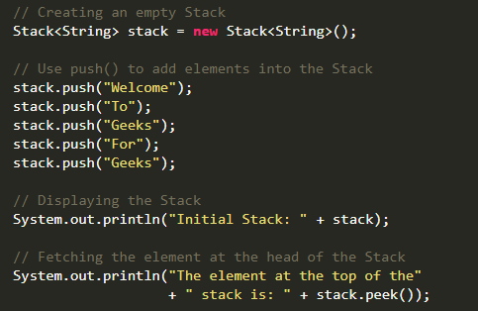
      3. pop()
         1. removes an element from the top of the stack
            1. 